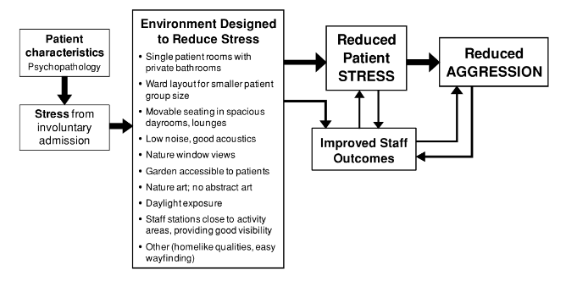

Jacqueline Guerra 2017-2018: Design Features, General Design Considerations, and Exposure to Behavioral Health
Evidence-based design (EBD) has become the primal source of progress for planning and design in healthcare architecture. EBD supports the process of going beyond meeting minimal requirements and into providing the best operational environment for patients, staff, and visitors as the optimal solution. Stated by some of the most recognized researchers in healthcare architecture, the information found on the topic of behavioral health environments is minimal and insufficient to inform the design process. Along with the limited research available in Mental and Behavioral Health (MBH) there is also awareness of clear issues such as its wide range of settings and diagnoses, and controversy in the topics of security, privacy, and safety. The objective of this paper is to challenge the boundaries of limited research by offering a review of primitive articles from recognized expertise in mental and behavioral health, which will assist in the initial stage of understanding the design to encourage a dialogue, raise questions, and continue the development of strong evidence for MBH. A focus on environmental psychology issues, design features that reduce stress and foster reduced aggression, and referenced examples of successful mental and behavioral health design, will help identify best practices for design and layout.

